**CO 2 PROGRAMS**

**1 Program to find the factorial of a number**

n=int(input('Enter a number : '))

f=1

for i in range(1,n+1):

f=f*i

print ('Factorial of',n, '=',f)

**Output**



**2 :Generate Fibonacci series of N terms**

n = int(input("Enter the limit : "))

a = 0

b = 1

sum = 0

count = 1

print("Fibonacci Series :",end= " ")

while(count <= n):

print(sum, end = " ")

count += 1

a = b

b = sum

sum = a + b

**Output**

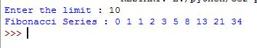

**3 Find the sum of all items in a list**

list1 = [10, 15, 20, 25, 30]

total = sum(list1)

print("Sum of list : ",total)

**Output**



**4 Generate a list of four digit numbers in a given range with all their digits even and the number is a perfect square.**

from math import sqrt as s

for i in range(1000,10000):

if s(i)==int(s(i)) and i%2==0:

print(i,end=" ")

**Output**



# CO 2 :Pgrm 5

**Display the given pyramid with step number accepted from user.**

rows = int(input("Enter the number of rows: "))

for i in range(1, rows+1):

for j in range(1,i+1):

print(i * j, end=' ')

print()

**Output**

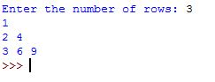  
**CO2_6:**

test_str=str(input("Enter the string : "))

freq = {}

for i in test_str:

if i in freq:

freq[i] += 1

else:

freq[i] = 1

print ("Count of all characters : "+ str(freq))

**OUTPUT:**

>>> %Run Co2_6.py

Enter the string : programming lab

Count of all characters : {'p': 1, 'r': 2, 'o': 1, 'g': 2, 'a': 2, 'm': 2, 'i': 1, 'n': 1, ' ': 1, 'l': 1, 'b': 1}

>>>

# CO 2 :Pgrm 7

**Add ‘ing’ at the end of a given string. If it already ends with ‘ing’, then add ‘ly’**

str=input("enter a string:")

print("inputed string is:",str)

if(str.endswith("ing")):

str=str+'ly'

else:

str=str+'ing'

print("the formated string is:",str)

**Output**

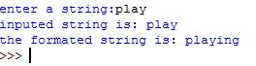

# CO 2 :Pgrm 8

**Accept a list of words and return length of longest word.**

a=[]

n= int(input("Enter the number of elements in list:"))

for x in range(0,n):

element=input("Enter element "+ str(x+1) )

a.append(element)

max1=len(a[0])

temp=a[0]

for i in a:

if(len(i)>max1):

max1=len(i)

temp=i

print("Longest Word:",temp)

print("Length of longest word :",max1)

**Output**

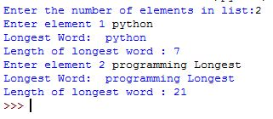

# CO 2 :Pgrm 9

**Construct following pattern using nested loop**

n= int(input("Enter the limit:"))

for i in range(n):

for j in range(i):

print ('* ', end="")

print('')

for i in range(n,0,-1):

for j in range(i):

print('* ', end="")

print('')

**Output**

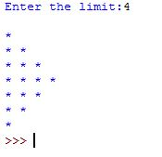

# CO 2 :Pgrm 10

# 

def factors(n):

print("The factors of",n,"are:")

for i in range(1,n+1):

if n%i==0:

print(i)

n=int(input("Enter a number:"))

factors(n)

**Output**

>>> %Run co2_10.py

Enter a number:4

The factors of 4 are:

1

2

4

>>>

# CO 2 :Pgrm 11

s_area=lambda a:a*a

r_area=lambda a,b:a*b

t_area=lambda a,b:1/2*a*b

print("area of sqr:",s_area(15))

print("area of rec:",r_area(10,20))

print("area of tri:",t_area(30,20))

**Output**

>>> %Run co2_11.py

area of sqr: 225

area of rec: 200

area of tri: 300.0

>>>